Organizational Behaviour Summary
- Week 1: History of OB – a field of study investigating the impacts that individuals, (personality, perception and motivation) groups (group dynamics and leadership) and structure (culture) have on behaviour within organisations. Aim is to apply this knowledge to improve an organisations effectiveness (innovation and creativity)
  - Classical view of OB: scientific management (Taylor) and Max Weber’s bureaucracy:
    - Machine processes are the ideal processes for us to copy. Employee psychology can’t be understood, so pressure employees to follow a manual and act like machines. Standardization and extrinsic motivation
  - Hawthorn experiment (Mayo): human relations view of OB – employee psychology is an important predictor of work performance.
  - Contingency view of OB: effectiveness of each view depends on the situation e.g. skilled v unskilled work. This is what adaptive leadership is based on.
- Week 2: personality, a trait possibly remaining constant throughout lifetime, determines a person’s general style of interacting with others
  - MBTI is a widely used personality assessment tool classifying extroversion v introversion, sensing v intuition, thinking v feeling and judging v perceiving.
    - 4 personality characteristics and 16 personality types
    - Problematic as not based on scientific theory and easy to personality fake in high stakes situations e.g. job applications. Doesn’t predict organisational outcomes.
  - Big Five is a superior method developed scientifically. Generates hundreds of personality items and used confirmatory factor analysis to generate 5 personality dimensions. Validated in many cultures.
    - Extraversion, agreeableness, conscientiousness, emotional stability and openness to experience
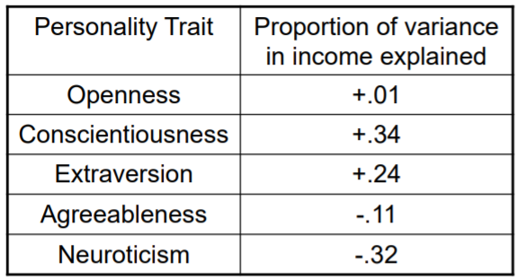
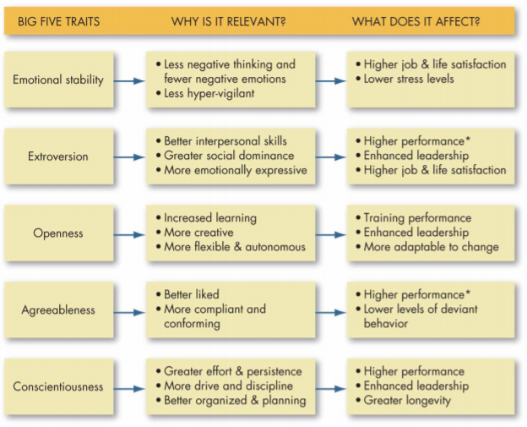
    - Effective predictor of organisational outcomes

  - Antecedents of personality: heredity (most significant) and environmental e.g. socioeconomic status.
    - Aging can affect ability but not basic personality
    - These personality traits then affect outcomes i.e. job satisfaction, performance and income.
  - Should companies use personality testing in hiring processes? Job candidates fake their personality (Birkeland), whether intentional (faking specific dimensions for specific jobs) or unintentional (selective memory)
    - Further, can perception cause us to unintentionally fake our personality?
  - Alternative ways of measuring personality – computer-based personality judgements using social media data (Youyou)
- Week 3: culture. Socialisation, PO and ASA and culture antecedents, characteristics, strength (tightness/looseness) and outcomes (through socialisation).
  - System of shared beliefs + assumptions held by employees – implicit control system
    - Characteristics – degree of: individualism, adaptability, results orientation, people orientation, collaboration and collectivism, integrity
    - Strength – tight (many norms and strong enforcement) v loose (few norms and weak enforcement).
  - Cultures influence us through socialisation – process that adapts employees to culture. Underlying process is conformity, from group dynamics, influenced by colleagues’ behaviour and statements.
    - This results in employees knowing which perspectives and behaviours are acceptable, and how to do things.
    - Prearrival, encounter and metamorphosis are the stages of socialisation
  - Potential reverse causality that people select cultures, rather than cultures affecting people’s behaviours. Idea is our personalities determine which culture we join
    - PO fit – people are attracted to and selected by organisations based on match between personality and culture. Good PO fit = selection, promotion, job-satisfaction and performance
    - ASA theory – adds a step of attrition, where misfits are more likely to leave the organisation, further increasing employee homogeneity
  - Antecedents of culture: functionality, leadership trait theory and leadership experience theory.
    - Cultural Darwinism – tightness and looseness across 50 US states
    - Leader-trait perspective – leaders create cultures based on their own personality traits.
    - Cultural transfer perspective – leader consider functionality of cultures, but may fail to create optimum culture due to bounded rationality or availability bias. So, they rely on available information (their past experience).
- Week 4: perception is the interface between stimuli and receiver, which helps us organise our sensory impressions to give meaning to and interpret our environment
  - We can’t trust our perception because it causes us to lose critical information – which information we lose depends on our culture and background
    - Holistic v analytical perceptions and relationship-based v rules-based perceptions.
    - From the West to East, people perceive differently the same objective stimuli, i.e. perceptual biases exist
  - Our perception is bias because of bounded rationality theory, leading to availability bias, anchoring etc.
    - Miller – people cannot process more than 7 pieces of information simultaneously
    - We use shortcuts, generating alternatives from experience and selecting solutions that satisfice our utility.
  - Typical biases – availability bias, anchoring bias, hindsight bias, escalation of commitment, randomness errors
- Week 5: motivation. Performance = f(motivation x ability). Motivation is the extent to which persistent effort directed towards a goal: motivation = f(effort, persistence, goal)
  - Content-based theories – profile universal individual needs that motivate behaviour e.g. Maslow’s Hierarchy of needs, ERG theory. Once satisfied, we are motivated.
    - Recent focus on ‘meaningful’ work – self-actualisation and belongingness
  - Process-based: more important is the cognitive calculation between our effort, behaviour, performance, and rewards.
    - Motivation = f(Expectancy, instrumentality, valence)
    - Limitations of expectancy theory – performance not always measurable (link to group dynamics) and is it realistic to increase valence w personal rewards
  - Contemporary theories combine the two, e.g. self-determination theory (which links to why empowering leadership can improve motivation) and goal-setting theory
    - Intrinsic motivation > extrinsic motivation, money undermines sense of self-determination
    - However SDT is wrong – money is important, but intrinsic factors are too – recognition,
  - Mary Kay case study
- Week 6: creativity, innovation, and innovation diffusion.
  - Component theory, dual pathway to creativity, creativity template
  - Innovative companies don’t have to be creative
  - Innovation diffusion is difficult, and important
- Week 7: group dynamics. Groups fail to outperform best person because of conformity pressure and hidden profile.
  - These link to socialisation of culture
  - Diffusion of responsibility can encourage social loafing

